Operating System Week 10-11

Name : Tanishq Vyas
SRN : PES1201800125
Section : H
Semester : 5
Branch : CSE

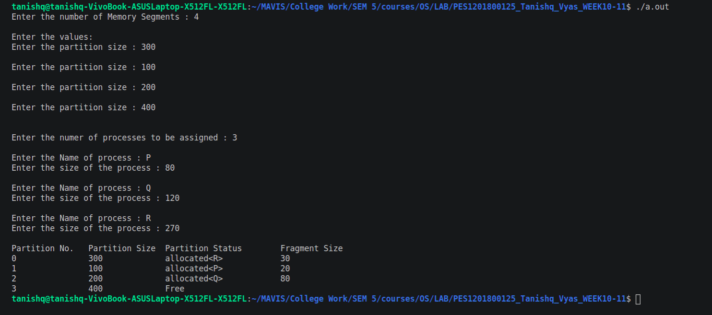

Fig : Execution for Best Fit Algorithm

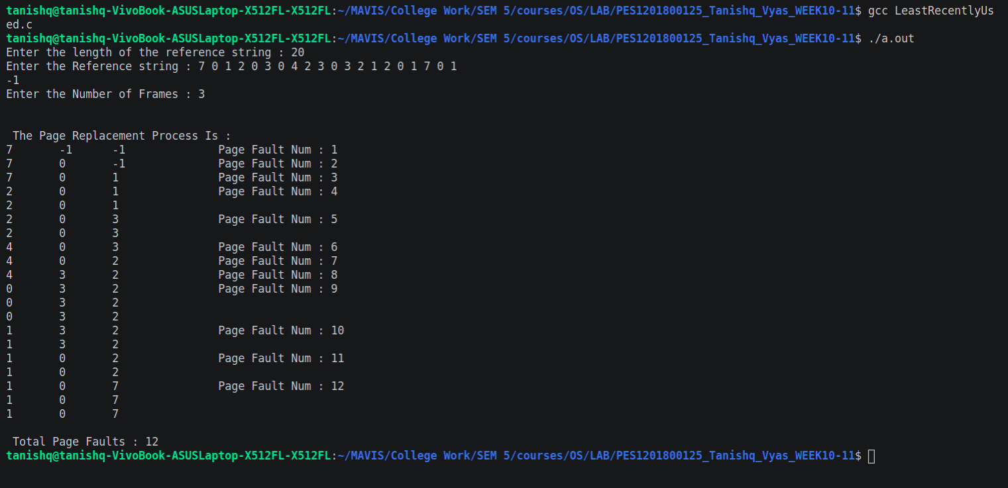

Fig : Execution for Least Recently Used Algorithm

